***Online Library Management System***

***Submitted By:***

* Md. Nasir Uddin
* Md. Aliul Ajim
* Parmita Das Gupta
* Subbir Jahan Chowdhury

**ABSTRACT**

Library is place where all kind of books are available. Online Library Management system is a web based application. This system contains list of all the books and can be accessed by remote users can connect from anywhere in the campus and can access some fields but to get full list and available books user must be registered. This system is three tier architecture.

Client sends requests, on receiving the request the server processes it and extracts the data from database and sends the result back to the client. This system provides separate interface and login for admin, students and faculties. Admin can modify database.

Users can search for books and send request for specific books. According to the request, Admin issue the book for that student. Students can view the issue and return dates of the books. This system generates reports that can be used in analyzing the library performance. Thus the management can take appropriate steps to improve the facilities.

**INDEX**

|  |  |
| --- | --- |
| **S. N** | **CONTENTS** |
| 1 | **INTRODUCTION** |
| 2 | **SYSTEM SPECIFICATIONS** |
| 3 | **PROJECT MODULES** |
| 4 | **Database Tables** |
| 5 | **OUTPUT SCREENS** |
| 6 | **CONCLUSION** |
| 7 | **Future Scopes** |

**INTRODUCTION**

Library Management System consists of list of records about the management of the details of the students and the issues going on and also about some books. This is a online based application. The project has three modules namely- User, Registration and Admin. According to the Modules the Admin and User can manage and do their activities in easy manner.

As the modern organizations are automated and computers are working as per the instructions, it becomes essential for the coordination of human beings, commodity and computers in a modern organization. This information helps the students to get their specific books.

The administrators and all the others can communicate with the system through this project, thus facilitating effective implementation and monitoring of various activities of libraries.

**System Specifications:**

Hardware Requirements:-

* Windows 10
* 4 GB Ram
* 500 GB Hard Disk

Software Requirements: -

* **Operating System :** Windows 7, 8, 10
* **Software :** Net beans Ide
* **Programming language :** Java ,Html, Jsp
* **Framework :** stratus, hibernate
* **Web-Technology :** Java Web Technology
* **Back-End :** Mysql Server 5.1
* **Web Server :** Jboss-eap-server 7.00

**PROJECT MODULES**

MODULES USED:-

The proposed system categories and follows these modules to implement

**Login component**

1. Administrator
2. Member

**Administrator Component**

1. Administrator

**Admin Manager Component**

1. Admin Manager
2. Issue Books

**Student Component**

1. Books Details

MODULES DESCRIPSTION:-

**Member**: Using login id and password member can the use Library online where users can search for books. They can recommend for new books by just sending request to the admin from any where in the campus. They can view the issue and return dates of any book .

**Registration:** In the Registration module, user has to register himself by supplying his personal information which gets store in data base which are using as backend. By registering himself user will get his login id and Password so that he can access Library online.

**Admin:** Admin is a person who manages the Library. He has the permission that he can access the database. There are some tasks which are performed by the Admin like:

* Addition of a new book.
* Updating of the book.
* Remove Member
* Searching of the book.
* Issue the books

**Database Tables**

1.book_list:

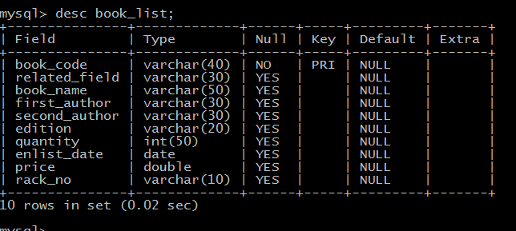

2. lib_members:

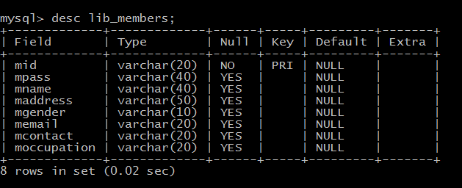

3.issue_book:

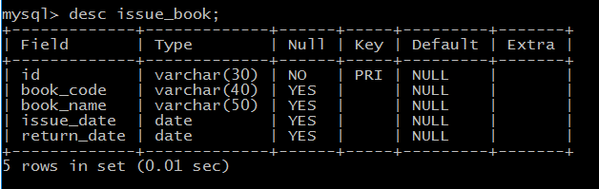

**Output Screen**

**Home page:**

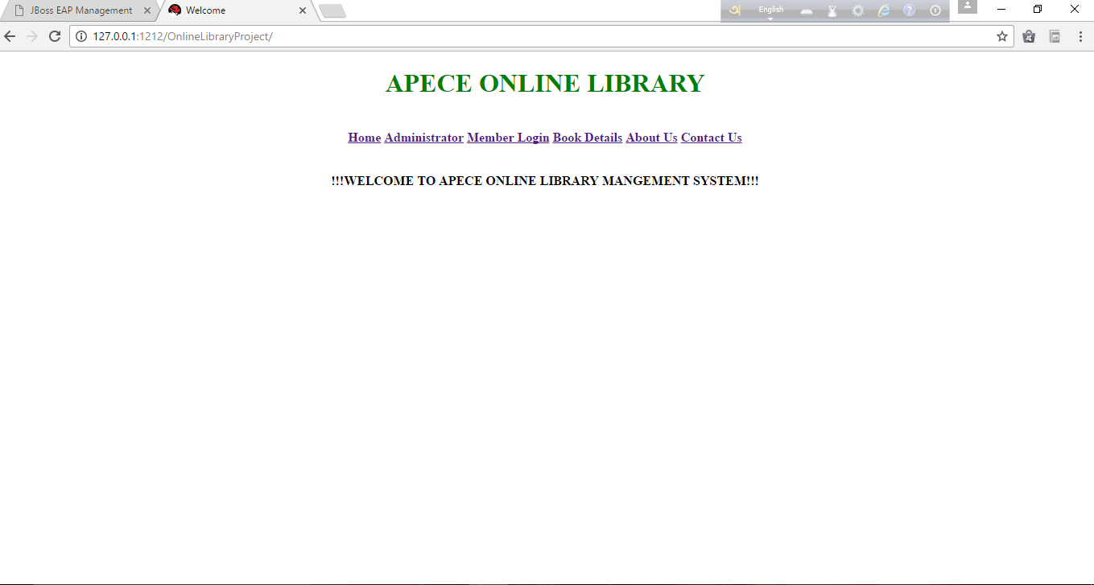

**Admin :**

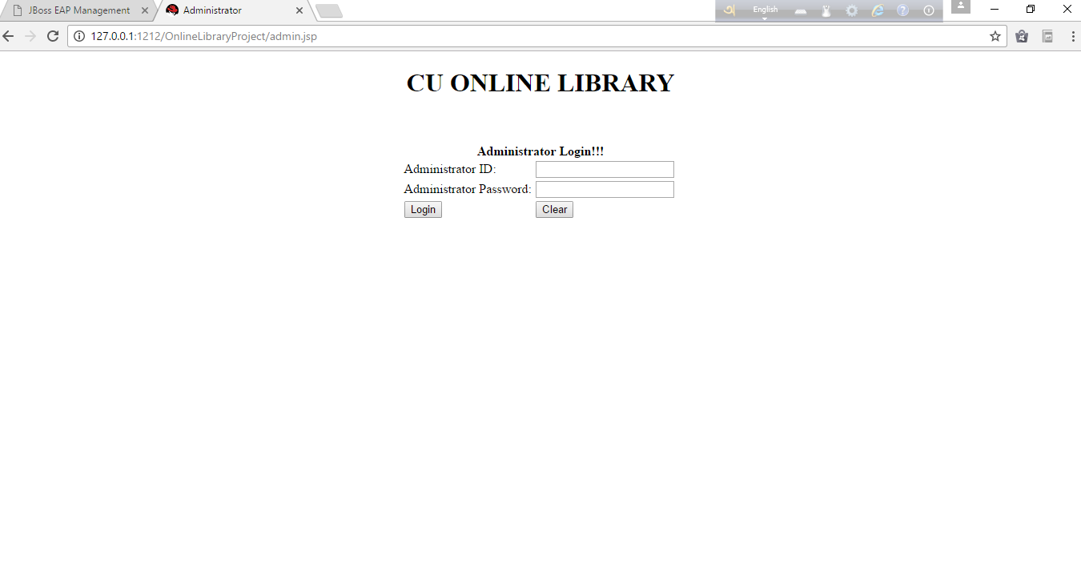

**Book Information:**

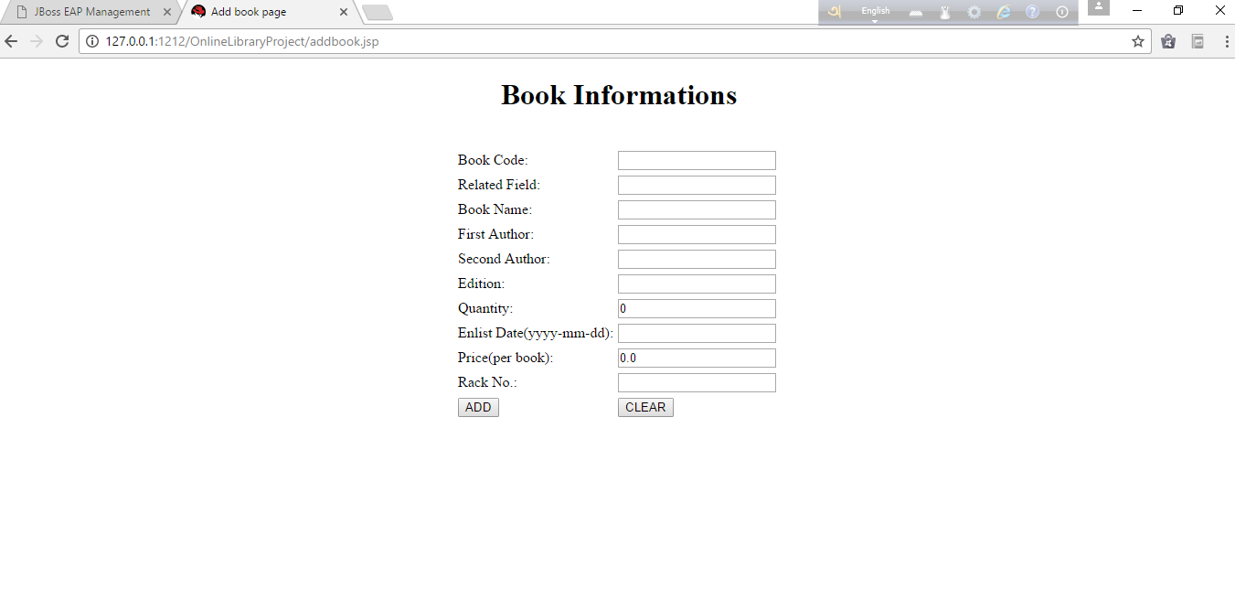

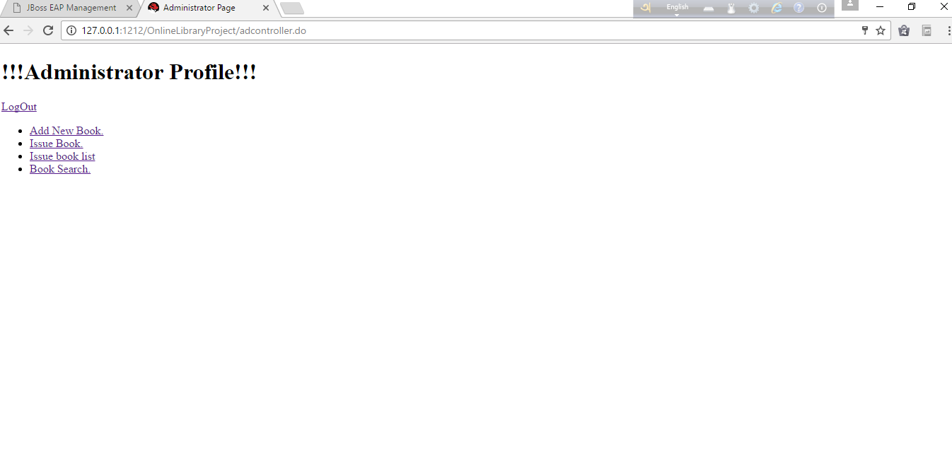

Search:

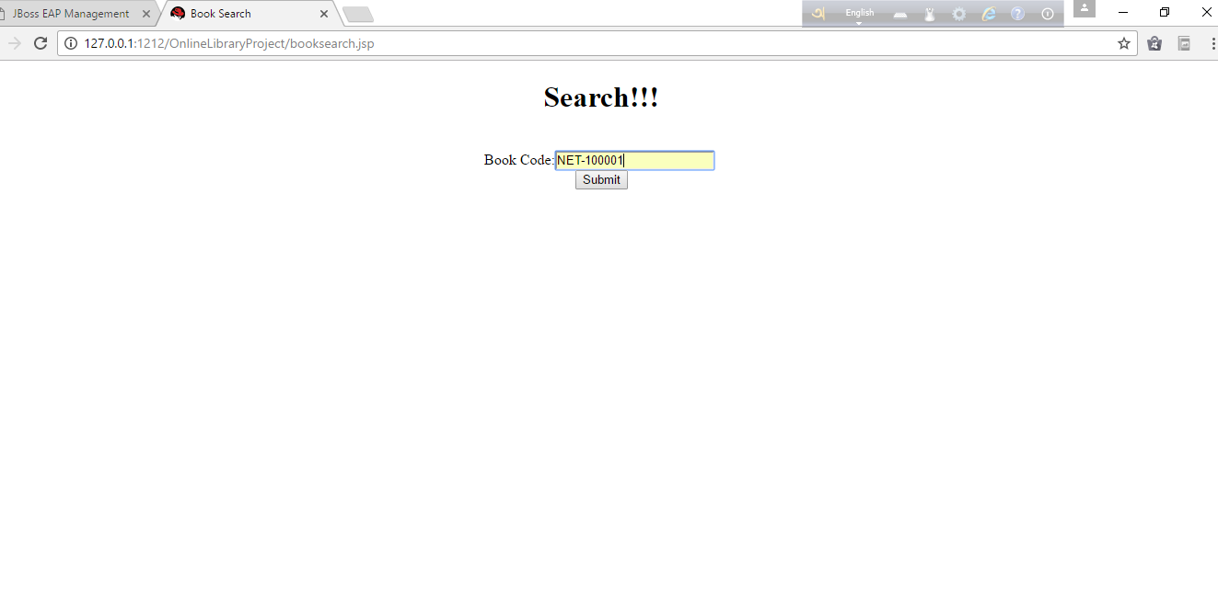

**Book list:**

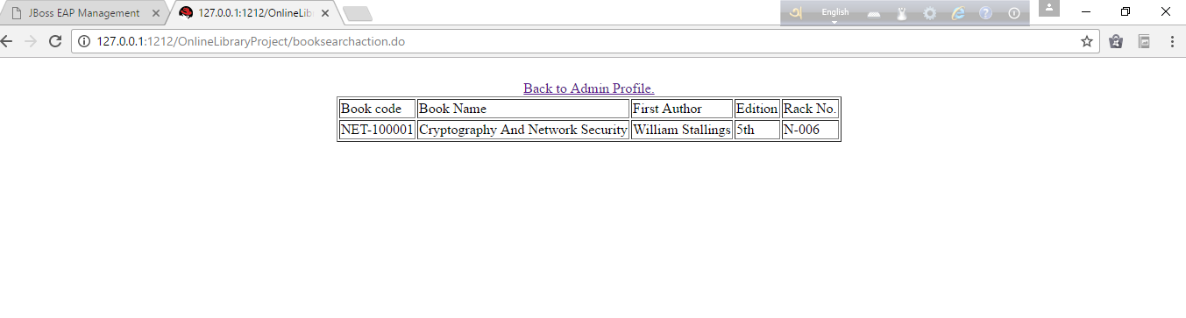 T

**Issued Book:**

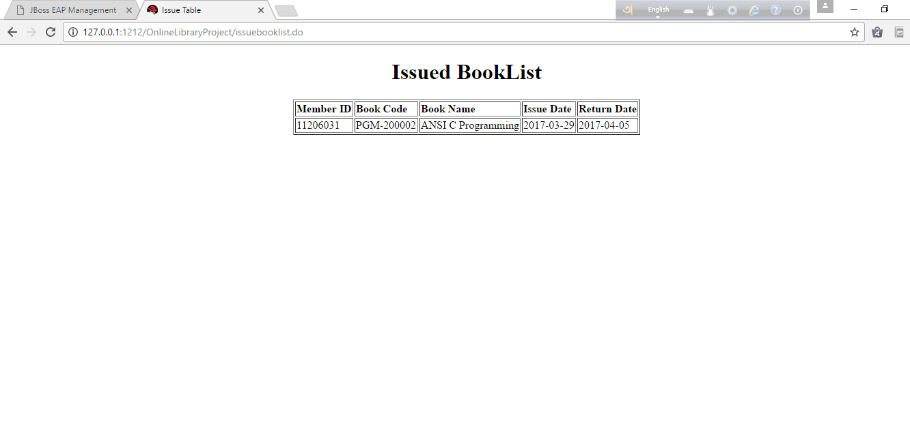

**Member Login:**

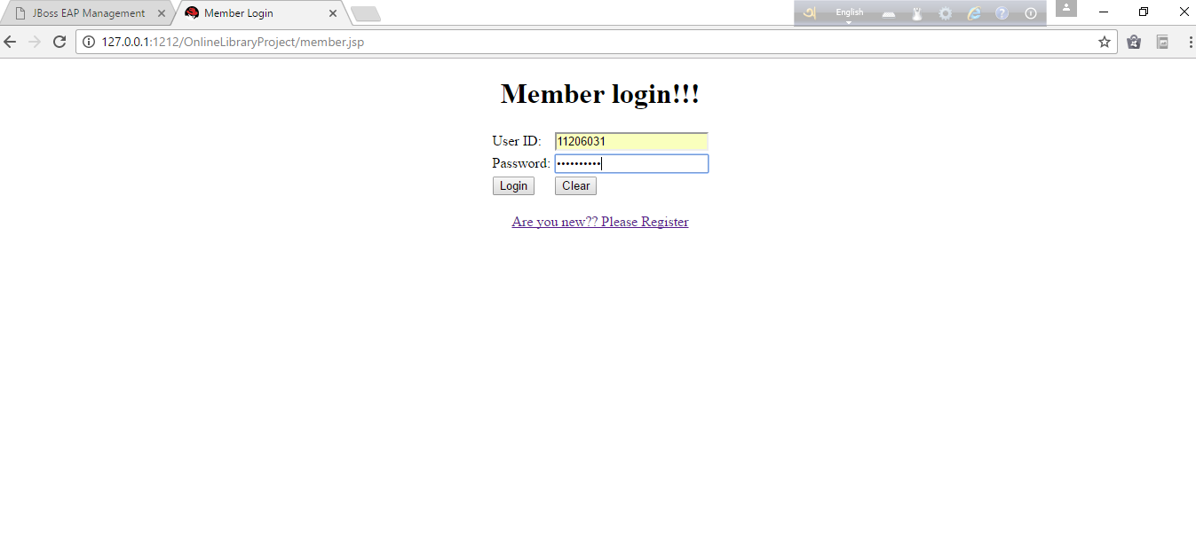

**Registration Form:**

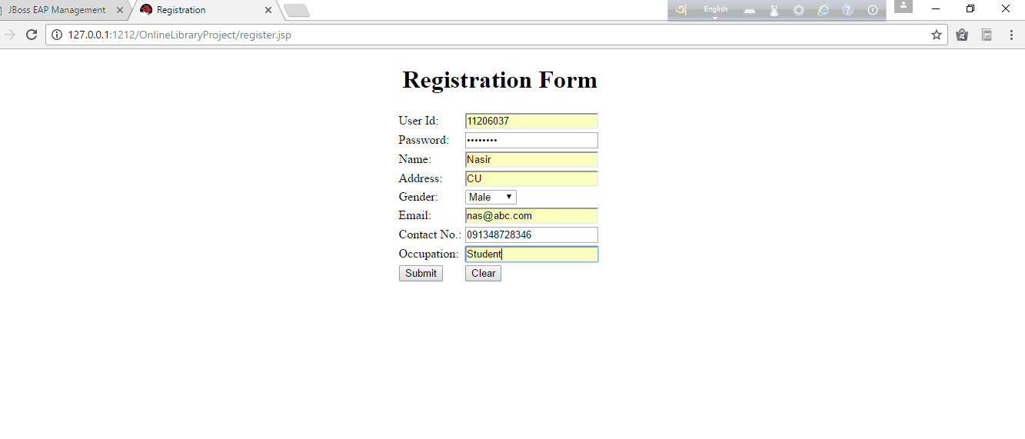

**Registered:**

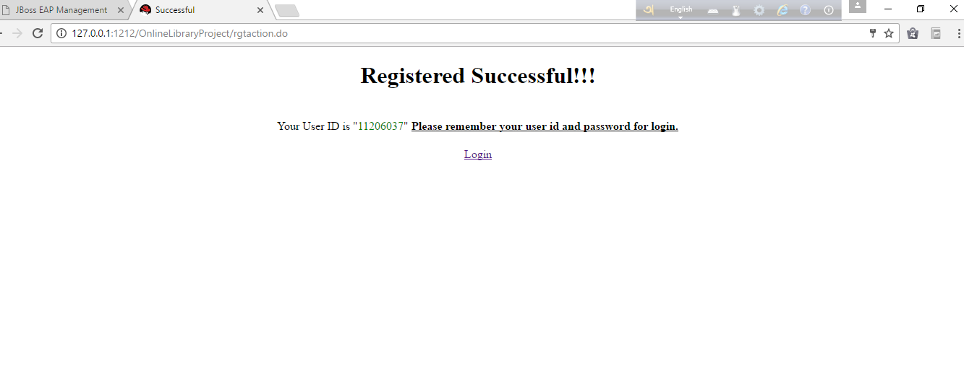

**FUTURE SCOPES**

This application avoids the manual work and the problems concern with it. It is an easy way to obtain the information regarding the various products information that are present in the Library of a particular University.

We have worked hard in order to present an improved application better than regarding the information about the various activities. Still, we found out that the project can be done in a better way. Primarily, when we request information about a particular books it just shows the availability of the books , books details . Next we can improve the facilities for the registered member to read the books .The next enhancement that we can add renew option for the members who already issued books.

**CONCLUSION**

The package was designed in such a way that future modifications can be done easily. The following conclusions can be deduced from the development of the project.

* + Library Management System of the entire system improves the efficiency.
  + It provides a friendly graphical user interface which proves to be better when compared to the existing system.
  + It gives appropriate access to the authorized users depending on their permissions.
  + It effectively overcomes the delay in communications.
  + Updating of information becomes so easier.
  + System security, data security and reliability are the striking features.
  + The System has adequate scope for modification in future if it is necessary.